**Bootstrap Info**

1. For applying the bootstrap we have to give the link of the bootstrap in the stating of the program in the head tag
2. We can only use bootstrap if the site is having different containers
3. We can make the site responsive by the help of the different container
4. py-5 means the padding equal to the 5px
5. my-4 means the margin equal to the 4px

*In above two cases the digits can be changed

1. In the fluid width container it is end to end in the page and it does not have any width

Eg.<div class=”container-fluid my-4 panel panel-blue”>Hello friends</div>

1. We can make some space between the screen and the components by the help of the container class in the div

Eg. <div class=”container”>

<h1>Neel Shah</h1>

</div>

1. For the margin from top we write mt-5;
2. For making any change in the bootstrap we have to first write it in the google and then see which class is used in it and then make it chage

i.e for background color < div class=”jumbotron bg-light”>

🡪We have to write that class into the class continue only not outside

1. Bootstrap has given all the property of the css in the form of the class, i.e. for using the float property we have to use it directly

🡪Just find it from google by finding like <property-name> bootstrap(explore it)

1. We can set the width of the image by the following code :

<img src='1.png' width="5%"></img>

1. We can also disable an button or any function, If the nothing is written in it by :

<button disabled={text.length===0} className=”btn btn-primary mx-1 my-1 onClick={handleUpClick}”>Convert to uppercase</button>

1. In bootstrap there are the 12 grids in an page and we make the row and columns in it by the help of the code like following :
2. And we can the different classes are used for defining the size of the coloumn :

col-, col-sm-, col-md, col-lg-, col-xl

🡪One example of the using it is :

<div classsName=”col-md-4”></div>

*Here we can use any class as per requirement and the 4 indicates the size which it holds over the grid of 12

1. We can centre the cards or the other elements in the webpage by using the div tag with the following class:

<div class=”d-flex justify-content-center”>

<Any-Tags>

<Any-Tags>

</div>

1. Always prefer the Microsoft edge for the development instead of the chrome as some times in the chrome the statements on the console is not printed
2. We can also check the performance of the web app by selecting tools from the browser and for it we have to go to browser and there we have many selection like sources, console, network(No throteling🡪check different networks), performance, memory, security, **lighthouse(make an report before publishing)**
3. In bootstrap we can make the navbar to be stuck on the page by the help of the adding the -following class on the className of the navbar : **sticky-top**
4.  this is called as the ham-burger
5. We can get the error or the special box like pop-up in the screen in the website by the help of the bootstrap’s modal
6. By using the d-none in the class/className of the button the button disappears from the website, Example

**<button className=”btn btn-primary d-none ref={ref}”>Click Me</button>**

1. We can set the value of the any thing in the html by the help of the value={}, Example

**<input type=”text” value={note.title} onChange={onChange}…/>**

1. (I.M.P.)from the bootstrap 5 the **text-right** and **text-left** has been removed and instead of that, we can use the **text-start** and **text-end**
2. In jsx we can give the style to the tag by, example

**<img src=”map_image.png” style={{width: ‘100%’}}></img>**

1. In the bootstrap, we can also give the single side padding or the margin instead of the all side margin or padding by the help of the keywords like t🡪For top, b🡪bottom and etc

🡪Hence, we can give the margin and the padding like: pt-3, and etc

1. We can give more than one bootstrap class to any of the element
2. For making the table to hover and responsive, we can use the two bootstrap classes as follow

**<div>**

**<div className=’table-responsive’>**

**<table className=’table table-hover’>**

**<continue here the sample table code stating from thread tag>**

**……**

**</table>**

**</div>**

**</div>**

**</div>**

1. For making the content of the navbar to be aligned to the right side of the navbar we will take the help of the ms-auto class, As shown below:

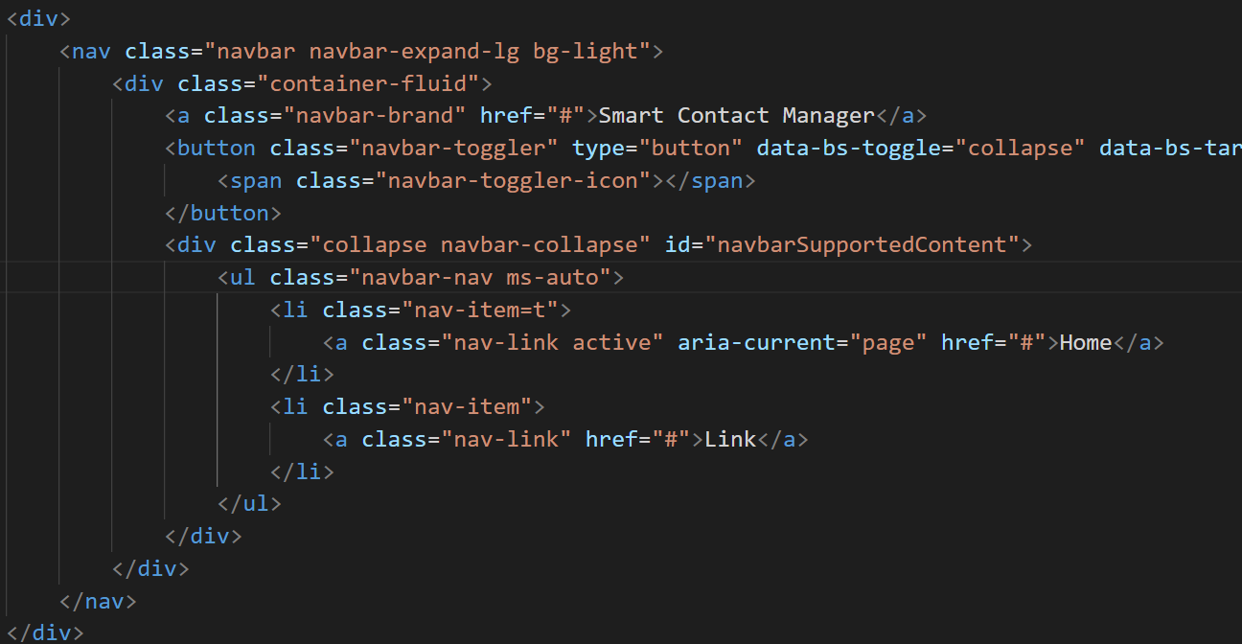

🡪And by doing that the result would be like:



1. For finding if the given check box is selected or not:



🡪Here the terms is the id

1. The pagination system is implemented in the smart contact’s website, Refer it’s ViewContact component to learn about it, Example code of it is as shown below(Not-whole):

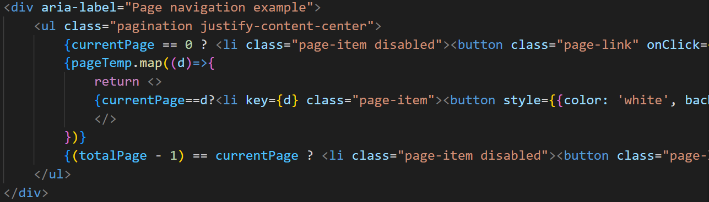

🡪Directly pagination in the bootstrap is not found, Search in google than only it is found